**Strategy Document: Cyclistic Customer Demand Project**

**Sign-off matrix:**

| **Name** | **Team / Role** | **Date** |
| --- | --- | --- |
| Shareefah Hakimi | Program Manager | Apr 21, 2023 |

**Proposer:** Cora Micsunescu, BI Analyst

**Status:** Draft> Under review > Implemented | Not implemented

**Primary dataset:** Customer dataset

**Secondary dataset:** Geographic aggregation dataset on bike station locations

## User Profiles: Intended audience are the stakeholders and team members of this project. They are to use this dashboard(s) to inform business decision-making and the creation of a new business plan.

# **Dashboard Functionality**

| **Dashboard Feature** | **Your Request** |
| --- | --- |
| Reference dashboard  (Should this dashboard be modeled on an existing dashboard? If so, provide a link and describe the similarity.) | Not applicable as there is no existing dashboard. |
| Access  (How should access to the dashboard be limited? Who needs to have access?) | Datasets will include customer(user data), which needs to be approved by Jamal Harris; access should be granted to all stakeholders and team members; access to other employees of Cyclistic will be granted on a case by case basis |
| Scope  (What data should be included or excluded in this dashboard?) | Data to be included:  Bike ID number  Customer ID number  Customer type (subscriber or one-time)  Starting and ending station numbers along with their geo coordinates  Weather data including precipitation  Zip codes and neighborhood names |
| Date filters and granularity  (Should the dashboard include date filters? If so, what time frame should be displayed by default? Should the dashboard include a “granularity” drop-down? If so, what granularity should be selected by default?) | One year of data by default; drop down filters by day/month/year; by default start with a day filter and allow the ability to filter by week/month/year. Especially to filter by winter, summer, spring months so that trends can be identified. |

# **Metrics and Charts**

### Chart 1

| **Chart Feature** | **Your Request** |
| --- | --- |
| Chart title | Bike rental stations |
| Chart type  (What type of chart needs to be created?) | Map |
| Dimension(s)  (What dimensions does this chart need to include?) | All bike rental stations with latitude, longitude, zip codes; bike ID numbers; starting and ending trips |
| Metric(s)  (What metrics are relevant to this chart?) | overlayed on top will be number of trips per day along with number of bikes available at each station |

### Chart 2

| **Chart Feature** | **Your Request** |
| --- | --- |
| Chart title | Customer Data |
| Chart type  (What type of chart needs to be created?) | Line chart |
| Dimension(s)  (What dimensions does this chart need to include?) | Number of subscribers; number of one-time customers; years/months/weeks |
| Metric(s)  (What metrics are relevant to this chart?) | Show the changes in number of subscribers, one-time customers over the years. |

### Chart 3

| **Chart Feature** | **Your Request** |
| --- | --- |
| Chart title | Weather Data |
| Chart type  (What type of chart needs to be created?) | Bar chart over map of bike stations |
| Dimension(s)  (What dimensions does this chart need to include?) | Overlay daily precipitation data over each bike station and its number of trips |
| Metric(s)  (What metrics are relevant to this chart?) | Precipitations by inches; wind speed; humidity; temperature; geo coordinates; number of start/end trips |

### Dashboard mockup

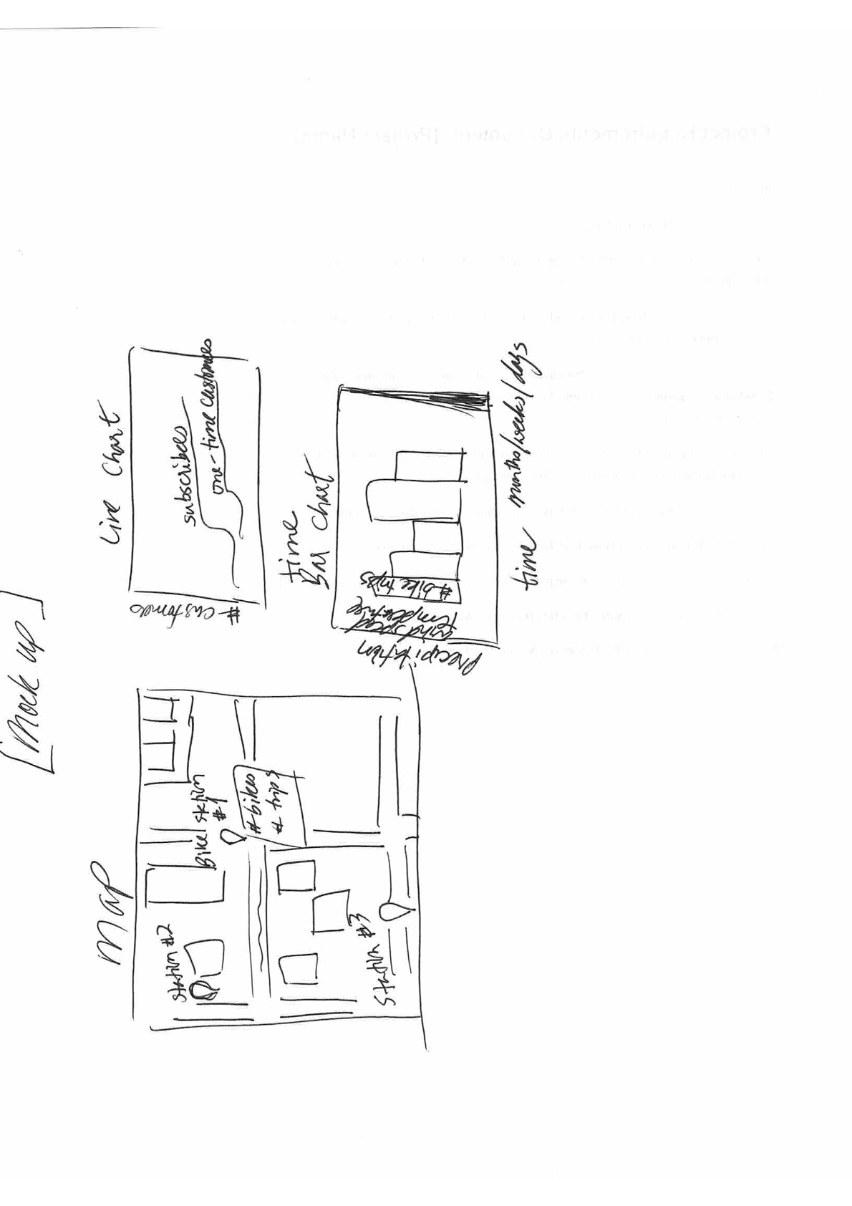

Follow-up questions:

1. Are there any sample dashboards or other bike share companies that have done similar research?
2. Does Cyclistic have any competitors? This could affect demand.
3. What about traffic conditions? Does a lot of traffic increase or decrease demand for bikes?
4. What role does the city of New York play in this? Do they just provide a license to operate? Or is there a potential for a deeper partnership by having the city construct more bike lanes in order to reduce car traffic congestion and increase demand for Cyclistic bikes.